To all Great Milton Parish Councillors:

You are summonsed to attend a PARISH COUNCIL MEETING on Monday 21st November 2011 at 7.30pm in the Pavilion:

114/11 Apologies for Absence
To receive apologies for absence from the meeting.

115/11 Register of Interests for this Meeting
To receive declarations of interest in matters on the Agenda.

116/11 Minutes of the Previous Meetings
To approve and sign minutes of the PC meeting held Monday 17th October 2011.

117/11 Matters to Report
To receive updates from Jenny Stoker, manager of the Maple Tree Children’s Centre, the neighbourhood policing team, District and County Cllrs if present and to receive progress reports regarding any actions (not appearing as Agenda items).

118/11 Correspondence and Public Discussion
To take questions from the public and receive items of correspondence.

119/11 Planning Applications
A To consider the following Planning Application:

Milton Lodge, Lower End, Great Milton, OX44 7NJ. P11/W1515 and P11/W1516/LB. Demolish modern kitchen extension, construct new extension in traditional materials with first floor gable ended extension under tiled roof. Open up blocked window on west elevation. (Amendment to planning permission P10/W1260 and P10/W1261/LB to alter the dimensions of the approved rear extension).

Le Manoir aux Quat Saisons, Church Road, Great Milton, OX44 7PD. P11/W1716/AG (Agricultural Notification). Proposed polytunnels.

B To review any planning decisions received.

120/11 Facilities for Young People in Great Milton
To discuss the next steps required in the planned provision of a club for young people within the parish.

121/11 Winter Preparedness
To assess the options for provision of snow/ice clearing equipment for the Parish and agree the expenditure on these and other winter preparations.

122/11 Village Maintenance Contracts
A To review the grass-cutting specification in advance of inviting tenders for a two-year contract to cut the verges.
B To review the village maintenance arrangements and consider using alternative / additional contractors and to revise the list of maintenance tasks currently required.

C To confirm the arrangements for the maintenance work due on the Silver Birch and to consider the introduction of a tree management policy and the regular inspection of trees in the Parish.

123/11 Great Milton Bus Shelters
A To review the responses to the Potts Close / Village bus shelter consultation and agree any necessary action.

B To consider expenditure in the region of £2-3,000 on an improved bus shelter on the London Road opp. Sandy Lane in Milton Common to be match-funded by an application to the County Council’s bus shelter grant scheme.

C To receive an update on the proposal to introduce a bus stop on Windmill Hill.

124/11 Financial Resolutions
A To authorise the following cheques for payment:

Joanna Botha. Salary. £322.18.
Joanna Botha. Bulletin advertising. £26.24 (3 hours x £8.747)
Jonathan Dudley. Bulletin Production. TBC
SODC. Dog bin emptying. £34.98
The Royal British Legion. Memorial Bell donation. £50.00

B To review the Effectiveness of the Internal Audit.
C To review and approve the conclusion of the external audit (Annual Return Year-ending 31st March 2011).
D To discuss the precept for 2011-12 and review and make amendments as necessary to the draft budget for 2011-12.

125/11 Any Other Business
This part of the meeting may be used to bring the Clerk’s attention to village maintenance issues, inform the meeting of any notices or diary dates and to propose future agenda items.

All members of the press and public are very welcome at this meeting. The date of the next Great Milton Parish Council meeting will be Monday December 19th 2011 at 7.30pm in the Pavilion.

Signed:
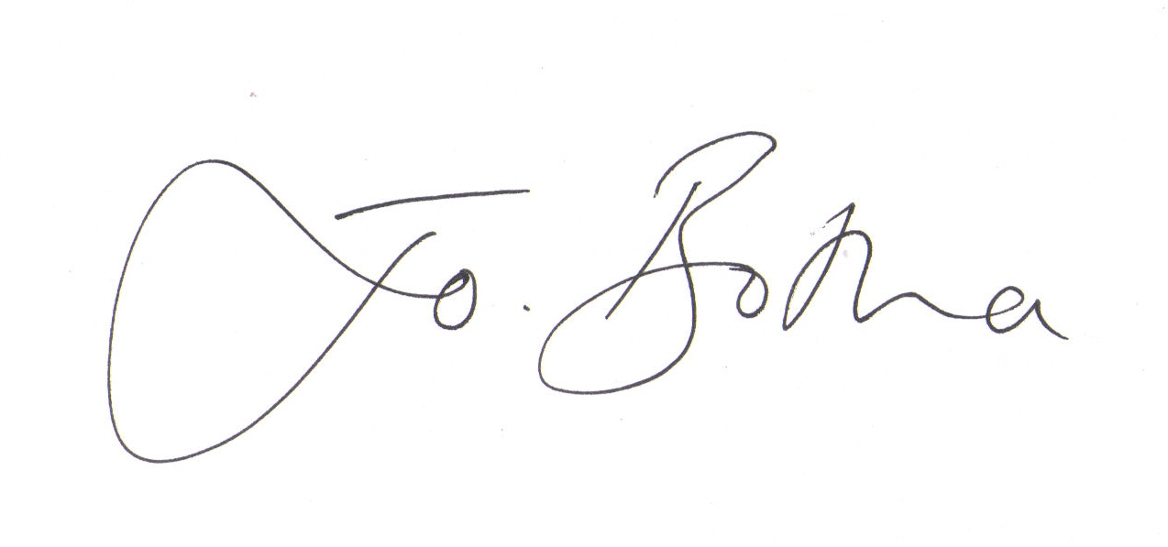
Joanna Botha, Clerk/Responsible Financial Officer

