To all Great Milton Parish Councillors:

You are summonsed to attend a PARISH COUNCIL MEETING on Monday 20th June 2011 at 7.30pm in the Pavilion:

AGENDA
62/11 Apologies for Absence
To receive apologies for absence from the meeting.

63/11 Register of Interests for this Meeting
To receive declarations of interest in matters on the Agenda.

64/11 Minutes of the Previous Meeting
To approve and sign minutes of the meeting held Monday 16th May 2011.

65/11 Matters to Report
To receive reports from the local PCSO, District and County Cllrs if present and any updates on actions since the last meeting (not appearing as Agenda items).

66/11 Correspondence and Public Discussion
To take questions from the public and receive items of correspondence.

67/11 Planning Applications
A To consider the following Planning Applications:

Le Manoir Aux Quat’Saisons, Church Road, Great Milton, OX44 7PD. P11/W0633 and P11W0634/LB (Listed Building Consent). Erection of two porches to two guest suites.

Land East of Crowthorne Kennels Milton Common (In the parish of Great Milton), OX9 2JX. P11/W0622/RET (Retrospective). Erection of a fence and gates up to 2.4 m high and three storage buildings.

B To review any Planning Decisions received.

C To report on the findings of the investigation into concerns raised by residents regarding the current development of agricultural buildings at Oxen Field, Thame Road, Great Milton (P06/W0135).

68/11 Reports of Anti-Social Behaviour
To discuss recent reports of anti-social behaviour in the village and agree any necessary action.

69/11 Overgrown Tree on Common Land
To discuss the problem of an overgrown tree by Old Cottage and agree any action and expenditure necessary.

70/11 Quality of Verge Cutting
To discuss the recent problems with the quality of the verge cutting, discuss the response from the contractor and agree any action.

71/11 Bulletin Production
To discuss and agree on expenditure required for the new production arrangements for The Bulletin.

72/11 Vacancies on the Parish Council
To co-opt members to the Parish Council or to discuss any necessary action should no volunteers be forthcoming.

73/11 Forthcoming Training and Events
To review forthcoming training and conferences, consider whether to attend and agree any expenditure.

74/11 Financial Resolutions
A To authorise the following cheques for payment:
Joanna Botha. Salary. £322.18
Joanna Botha. May Bulletin. £69.98 (8 hours x £8.747)
Joanna Botha. Expenses. TBC
Jonathan Dudley. May and June Bulletin. TBC
Countrywide Grounds Maintenance. Recreation Ground Cuts – 11th, 18th, 21st, 28th April, 12th, 20th, 27th May. £630.00
Berinsfield Community Business. Grass Verge Cuts – 12th, 25th April. £468.00
CPRE. Subscription. £29.00
Whiteleaf Printers Ltd. £365.00

B To review the VAT reclaim for the financial year ending March 31st 2011.
C To review the Annual Return for the Year-ending March 31st 2011 and approve Sections 1 & 2.

75/11 Any Other Business
This part of the meeting may be used to bring the Clerk’s attention to village maintenance issues, inform the meeting of any notices or diary dates and to propose future agenda items.

All members of the press and public are very welcome at this meeting. The date of the next Great Milton Parish Council meeting will be Monday July 18th 2011 at 7.30pm in the Pavilion.

Signed:
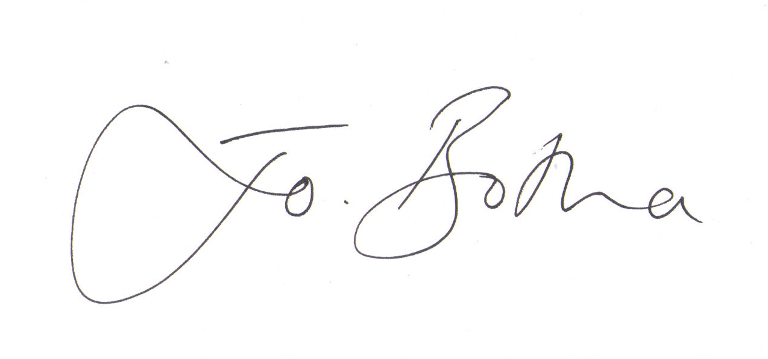
Joanna Botha, Clerk/Responsible Financial Officer

