To all Great Milton Parish Councillors:

You are summonsed to attend a PARISH COUNCIL MEETING on Monday 20th February 2012 at 7.30pm in the Pavilion:

14/12 Apologies for Absence
To receive apologies for absence from the meeting.

15/12 Register of Interests for this Meeting
To receive declarations of interest in matters on the Agenda.

16/12 Minutes of the Previous Meeting
To approve and sign minutes of the PC meeting held Monday 16th January 2012.

17/12 Matters to Report
To receive updates from the neighbourhood policing team, District and County Cllrs, the Clerk and receive progress reports (not appearing as agenda items), including:

A Facilities for Young People in Great Milton
B Matters for Highways
C Progress with Parish Council Action List

18/12 Correspondence and Public Discussion
To take questions from the public and receive items of correspondence.

19/12 Planning Applications
A To consider the following Planning Application:
Brannock, Lower End, Great Milton, OX44 7NL. P11/W2112/EX. Two storey extension. (Extension of time on P08/W1232).

B To review any planning decisions received and discuss any outstanding planning matters.

20/12 Parish Plan Production
To review the estimates and samples provided for printing the Parish Plan, select a supplier, agree any changes to the format and approve the expenditure.

21/12 Footpath Expansion
To consider the additional footpaths proposed by residents as part of the Parish Plan and agree a course of action.

22/12 Tree Planting on Common Land
To consider a request from residents to plant a small flowering cherry tree on Common Land by North End Cottage.

23/12 Financial Resolutions
A To authorise the following cheques for payment and to sign the related invoices:

Joanna Botha. February salary. £322.18.
Joanna Botha. Bulletin advertising overtime. TBC (? hours x £8.747)
Jonathan Dudley. Bulletin Production. TBC
Glasdon Manufacturing Ltd. Snospade – extendable shovel. £17.94
Earth Anchors. Dog bin. £97.20
Windmill Landscapes. Hedge Cutting. TBC
Dave Pullen. Village Maintenance. TBC
Three Village Hospital Car Service volunteers. Reimbursements for fuel. £66 in total.
Sylvia Kirby. Reimbursement for car service phone calls. £6

24/12 Grass Cutting Contracts (Public not admitted during this item)
To review the quotations supplied for both the Greens/Common Land and Recreation Ground grass cutting contracts and select a contractor for the 2012 and 2013 seasons.

25/12 Any Other Business
This part of the meeting may be used to bring the Clerk’s attention to village maintenance issues, inform the meeting of any notices or diary dates and to propose future agenda items.

All members of the press and public are very welcome at this meeting. The date of the next Great Milton Parish Council meeting will be Monday March 19th 2012 at 7.30pm in the Pavilion.

Signed: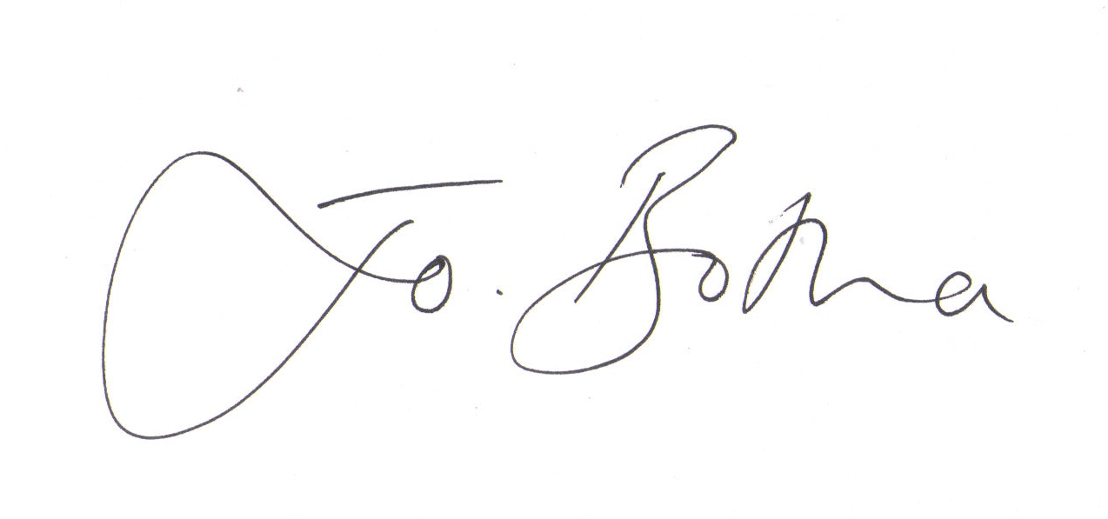

Joanna Botha
Clerk/Responsible Financial Officer

