To all Great Milton Parish Councillors:

You are summonsed to attend a PARISH COUNCIL PLANNING MEETING on Monday 15th August 2011 at 7.30pm in The Pavilion, Great Milton:
Agenda

- Apologies for Absence
To receive apologies for absence from the meeting

- Register of Interests for this Meeting
To receive declarations of interest in matters on the Agenda

- Planning Applications
To receive and consider the following Planning Applications:

A
Address: Le Manoir Aux'Quat Saisons, Church Road, Great Milton, OX44 7PD

Application Ref: P11/W1105 and P11/W1106/LB (Listed Building Consent)

Proposal: Erection of extension to Belle Epoque function suite.

All members of the public are welcome to attend this meeting.
If you would like to inspect the plans prior to the meeting, then this can be done via the South Oxfordshire District Council website http://www.southoxon.org.uk and searching under the application reference.

Signed:

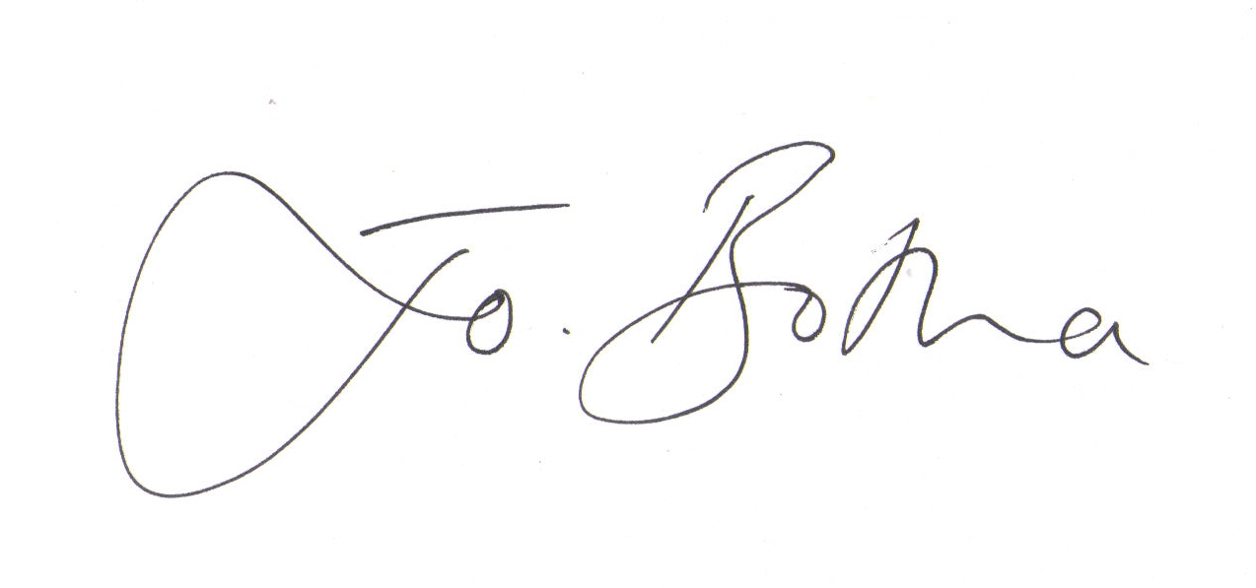

Joanna Botha, Clerk to Great Milton Parish Council

