To all Great Milton Parish Councillors:

You are summonsed to attend a PARISH COUNCIL MEETING on Monday 13th December 2010 at 7.30pm in the Pavilion:

AGENDA
134/10 Apologies for Absence
To receive apologies for absence from the meeting.

135/10 Register of Interests for this Meeting
To receive declarations of interest in matters on the Agenda.

136/10 Minutes of the Previous Meeting
To approve and sign minutes of the meeting held Monday 8th November 2010.

137/10 Matters to Report
To receive reports from District and County Cllrs if present and an update on actions since the last meeting not appearing as Agenda items.

  - Parking on the Greens
  - Resurfacing of Recreation Ground Access Way
  - Parish Plan

138/10 Correspondence and Public Discussion
To take questions from the public and receive items of correspondence, including the following:

  - OCC Highways – Letter of Introduction from Local Highways Representative
  - ORCC bulk buying scheme for domestic heating oil
  - Briefing note on changes to local Adult Social Care Teams
  - Public Notice inviting representations on South Oxfordshire’s ‘Proposed Submission Core Strategy Development Plan Document’ (Planning Policy)
  - Reminder about the Draft Local Transport Plan 2011 – 2030 Consultation

139/10 Planning Applications
A To consider the following Planning Applications:

12 Ashurst Court, London Road, Wheatley, OX33 1ER. P10/W1744/EX. Extension of
time for planning permission P08/W0080, (change of use of former agricultural storage building to B1 use).

Ardfield, The Green, Great Milton, OX44 7NP. P10/W1738. Infill extension to rear ground floor.

Tallis House, Lower End, Great Milton, OX44 7NF. P10/W1665 & P10/W1666LB. Extension and refurbishment of listed house; reinstatement as a single dwelling; removal of porch and alteration to roof line and listed building consent.

B To review the following Planning Decisions received:

Westlands, Lower End, Great Milton, OX44 7NJ. P10/W1382. (Granted)
Milton Lodge, Lower End, Great Milton, OX44 7NJ. P10/W1260 &P10/W1261/LB. (Granted)

C To receive any further updates on outstanding applications.

140/10 Development of a new Multi Use Games Area (MUGA)
To consider the Hard Surface Play Area (HSPA) Committee’s request to extend the school’s existing leases of playground areas from GMPC for a further 20 years and to review the plans for a new MUGA (multi use games area) consisting of two tennis courts/football pitch/basketball court etc. on the site, which would be for school use during school hours and for Parish use the rest of the time.

141/10 Financial Resolutions
A To authorise the following cheques for payment:

Joanna Botha. Salary. TBC
Manuel Stone. December Bulletin. £50.00
Jonathan Dudley. December Bulletin. TBC
Windmill Landscapes. Lychgate Lane strimming. £35.25
SODC. Dog hygiene bin service (Jan-Sep 2010). £102.75
Berinsfield. Verge Grass Cutting (October). £229.13
Spadeoak. 50% deposit for Recreation Ground Access Way. £3,495.63

B To review and approve the revised Standing Orders and Financial Regulations for Great Milton Parish Council.

C To review the Action Plan drawn up from the Internal and External Auditor’s recommendations.

D To review and approve the final budget for 2011-12.

142/10 Any Other Business

All members of the press and public are very welcome at this meeting. The date of the next Great Milton Parish Council meeting will be Monday January 10th at 7.30pm in the Pavilion.

Signed:
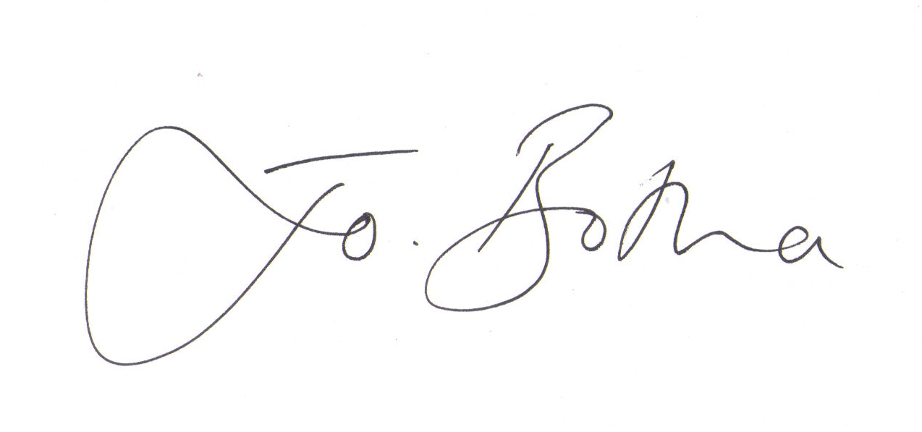
Joanna Botha, Clerk/Responsible Financial Officer

