To all Great Milton Parish Councillors:

You are summonsed to attend a PARISH COUNCIL MEETING on Monday 10th January 2011 at 7.30pm in the Pavilion:

AGENDA
01/11 Apologies for Absence
To receive apologies for absence from the meeting.

02/11 Register of Interests for this Meeting
To receive declarations of interest in matters on the Agenda.

03/11 Minutes of the Previous Meeting
To approve and sign minutes of the meeting held Monday 13th December 2010.

04/11 Matters to Report
To receive reports from District and County Cllrs if present and an update on actions since the last meeting not appearing as Agenda items, including the following:

- Extension of leases for school playground and new MUGA
- Resurfacing work on Recreation Ground Access Way
- Parish Plan

05/11 Correspondence and Public Discussion
To take questions from the public and receive items of correspondence, including the following:

- Letter of thanks from Thames Valley & Chiltern Air Ambulance
- Reply from the Oxfordshire Mobile Library Service

06/11 Planning Applications
A To consider the following Planning Applications:

Asda Stores Ltd, London Road, Wheatley, OX33 1YZ. P10/W1878. Proposed entrance lobby to existing store main entrance.

Lovegrove House, High Street, Great Milton, OX44 9NP. P10/W1923. Addition of new dining room/garden room at the rear of the property. Remodelling of WC roof plus minor landscaping work.

Westlands, Lower End, Great Milton, OX44 7NJ. P10/W1868/LB. Take down boundary wall and rebuild as a retaining wall.

B To review any Planning Decisions received.

C To receive any further updates on outstanding applications.

07/11 New Format Bulletin
To review the first issue of the new format Bulletin and receive any updates on changes to the production process and advertising.

08/11 Pegswell Lane – Grant Applications
To review and approve the grant application to the Oxfordshire Stronger Communities Fund and discuss any further applications to be made.

09/11 Grass Cutting Contract – Recreation Ground
To review and approve the proposed joint letter from Great Milton, Little Milton and Great Haseley Parish Councils requesting quotes from contractors for April 2011-March 2012.

10/11 Financial Resolutions
A To authorise the following cheques for payment:

Joanna Botha. Salary. £314.74
Manuel Stone. January Bulletin. £50.00
Jonathan Dudley. December and January Bulletin. TBC
Mike Henson Presentations. Hosting services. £70.50
Thames Water. Allotment supply Sept-Dec. £11.99

B To review a quarterly bank reconciliation with analysis of actual receipts/payments versus budget.

C To review the Action Plan drawn up from the Internal and External Auditor’s recommendations.

11/11 Any Other Business

All members of the press and public are very welcome at this meeting. The date of the next Great Milton Parish Council meeting will be Monday February 14th 2011 at 7.30pm in the Pavilion.

Signed:
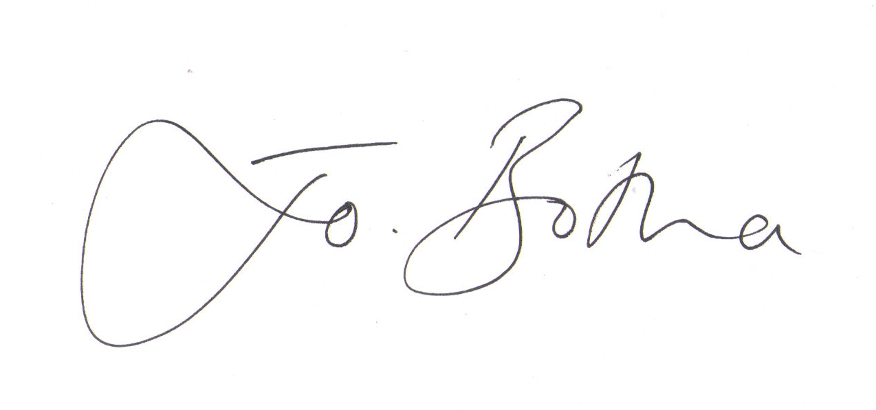
Joanna Botha, Clerk/Responsible Financial Officer

