To all Great Milton Parish Councillors:

You are summonsed to attend a PARISH COUNCIL MEETING on Monday 14th June 2010
at 7.30pm in the Pavilion:

AGENDA
69/10 Apologies for Absence
To receive apologies for absence from the meeting

70/10 Register of Interests for this Meeting
To receive declarations of interest in matters on the Agenda

71/10 Minutes of the Previous Meeting
To approve and sign minutes of the Annual PC Meeting held Monday 10th May 2010.

72/10 Matters to Report
To receive an update on actions since the last meeting not appearing as Agenda items and reports from District and County Cllrs if present.

73/10 Correspondence and Public Discussion
To receive items of correspondence and take questions from the public.

74/10 Planning Applications
A To receive and consider the following Planning Applications:

The Mill House, Great Haseley, OX44 7JA. P10/W0602.
Brook Bank, Church Road, Great Milton, OX44 7PB. P10/W0636.
Brook Bank, Church Road, Great Milton, OX44 7PB. P10/W0646/CA.
The Oxford Belfry, Brimpton Grange, Milton Common, OX9 2JW. P10/W0541.
The Cottage, Church Road, The Green, Great Milton, OX44 7NT. P10/W0514.
The Cottage, Church Road, The Green, Great Milton, OX44 7NT. P10/W0516/LB

B To review the following Planning Decisions received:

Planning permission has been GRANTED by SODC for:
Tudor Cottage, 1 London Road, Wheatley OX33 1JJ. P10/W0471.
Bentley House, London Road, Milton Common, OX9 2NU. P10/W0443
The Priory, Church Road, Great Milton. P10/W0312/LB & P10/W0311
Tudor Cottage, London Road, Wheatley. P10/W0397
The Old Stores, The Green, Great Milton. P10/W0366/LB & P10/W0104

Planning permission has been REFUSED by SODC for:
Land East of Crowthorne Kennels, Milton Common, OX9 2JX. P09/W1143/RET
Land East of Crowthorne Kennels, Milton Common, OX9 2JX4. P10/W0493/RET

C To receive any further updates on outstanding applications.

75/10 Parking on the Green
A To review the impact of the recent letters advising residents not to park on the Village Green and to agree what further action to take.

76/10 Donation requests
To discuss and agree whether to grant donation requests from:
A Oxfordshire Business Education Alliance.
B St. John’s Ambulance.
C Ryder-Cheshire Volunteers.

77/10 Development of the Bulletin and Web site
A To consider the options and costs for development of the Parish Council’s communications and agree how to proceed.

78/10 Development work at Le Manoir
A To receive an update on the temporary use of the field adjacent to Le Manoir during building work and its use as a car park.

79/10 Pegswell Lane
A To discuss and agree how to establish ownership of this area and how to fund the repairs to the old stone wall and other necessary improvements.

80/10 Duties as custodian trustee of Recreation Ground and Pavilion
A In order to meet the requirements of the current funding bid for the Pavilion refurbishment the Parish Council is required to discuss and agree the actions necessary to register the land with the Land Registry and the signing of a funding agreement with OCC that the land will not be sold.

81/10 Financial Resolutions
A To authorise cheques for payment.
B To receive the Internal Auditor’s report for the year-ending March 31st 2010.
C To review the Annual Return for the Year-ending March 31st 2010 and approve Sections 1 & 2.
D To approve the designation of £500 budgeted in 2009/10 for the Pavilion Refurbishment project into the reserves held on behalf of the Recreation Ground Management Committee.

All members of the press and public are very welcome at this meeting. The date of the next Great Milton Parish Council meeting will be Monday July 12th at 7.30pm in the Pavilion.

Signed:
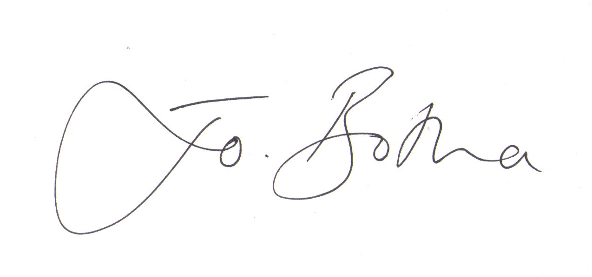
Joanna Botha, Clerk/Responsible Financial Officer

