To all Great Milton Parish Councillors:

You are summonsed to attend a PARISH COUNCIL MEETING on Monday 19th December 2011 at 7.30pm in the Pavilion:

126/11 Apologies for Absence
To receive apologies for absence from the meeting.

127/11 Register of Interests for this Meeting
To receive declarations of interest in matters on the Agenda.

128/11 Minutes of the Previous Meetings
To approve and sign minutes of the PC meeting held Monday 21st November 2011.

129/11 Matters to Report
To receive updates from, the neighbourhood policing team, District and County Cllrs if present and to review the action list and receive progress reports (not appearing as Agenda items), including:

A Parish Plan
B Facilities for Young People in Great Milton
C Village Maintenance Contracts
D Winter Preparations

130/11 Correspondence and Public Discussion
To take questions from the public and receive items of correspondence.

131/11 Planning Applications
A To consider the following Planning Applications:

Lantern Service Station, Old London Road, Milton Common (in the Parish of Tiddington and Great Milton), OX9 2JL. P11/W1796. Change of use from a service station to a workshop and vehicle sales.

Milton Lodge, Lower End, Great Milton, OX44 7NJ. P11/W1731. Alterations to the boundary walls. walls. (As amended by drawing No. N253-HE-26-0 REV A and accompanying email from agent dated 12th December 2011.)

B To review any planning decisions received.

132/11 The Sheppard Charitable Trust
To nominate a trustee for The Sheppard Charitable Trust to serve a four year term following the expiration of Mr John Davis’ term of office in January 2012.

133/11 Pegswell Lane Maintenance
To review the proposals arising from the recent residents meeting and agree a course of action and any expenditure required.
134/11 Milton Common Matters
A To consider the reported need for a bus shelter and village gates for the Tetsworth side of London Road, Milton Common.
B To discuss any necessary action regarding the position of parked vans near the junction of London Road / A329.

135/11 Dog Bin for Grove Lane
To consider whether to purchase an additional dog bin for Grove Lane and agree the expenditure of both purchase and maintenance.

136/11 Co-option of Two Parish Councillors
To review the expressions of interest received and to resolve by a vote which candidates to co-opt onto the Parish Council.

137/11 Financial Resolutions
A To authorise the following cheques for payment and to sign the related invoices:

Joanna Botha. Salary. £322.18.
Joanna Botha. Bulletin advertising. £26.24 (3 hours x £8.747)
Jonathan Dudley. Bulletin Production. TBC
M40 CEG. Donation. £30.00
Mhp internet Ltd. £72.00. Web site hosting.

Jonathan Dudley. November Bulletin. To sign invoice only.

B To agree and authorise the precept for 2012-13 and to approve the final version of the budget for 2012-13.

138/11 Any Other Business
This part of the meeting may be used to bring the Clerk’s attention to village maintenance issues, inform the meeting of any notices or diary dates and to propose future agenda items.

All members of the press and public are very welcome at this meeting. The date of the next Great Milton Parish Council meeting will be Monday January 16th 2011 at 7.30pm in the Pavilion.

Signed:
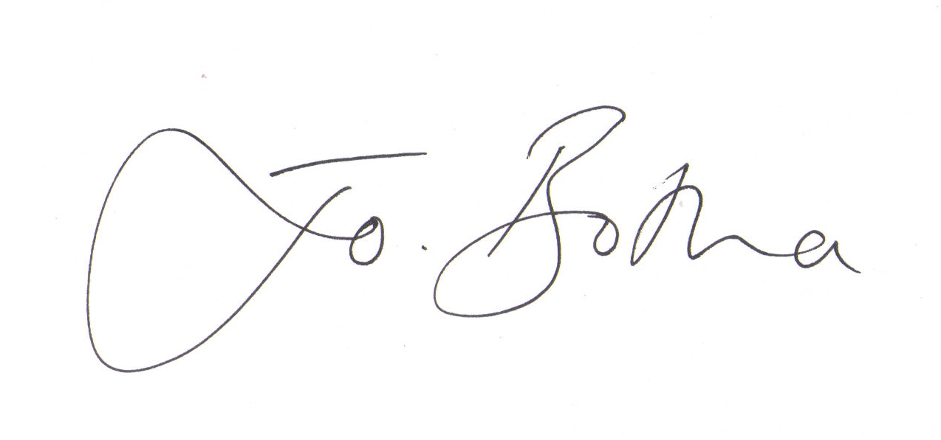
Joanna Botha, Clerk/Responsible Financial Officer

