11/02/2023

To the Chairman and members of Great Milton Parish Council

Dear Councillor

You are hereby summoned to the next meeting of Great Milton Parish Council, to be held at the Pavilion, Recreation Ground, Great Milton on Monday 20th February.

Public and Press are welcome to attend.

Yours sincerely,
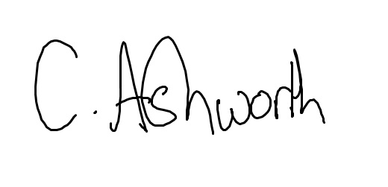
Chris Ashworth
Clerk & Responsible Finance Officer to Great Milton Parish Council

AGENDA

12/23 Apologies for absence

13/23 Co-option vote for new Parish Councillor to fill the current vacancy.
The Parish Council is to vote in the matter of Robert Cartwright becoming a member of the Great Milton Parish Council.

14/23 Variation of order of business

15/23 Declarations of members’ interests
To receive declarations of interest in matters on the Agenda.

16/23 Matters to report
To receive reports from County and District Councillors and other bodies as appropriate.

17/23 Correspondence and public discussion
A litter pick has recently been completed on the Thame Road up to the A239. There was a considerable number of branches, foliage and cuttings littering the verges. It has been asked if there is the possibility of a working party from the Parish or South Oxfordshire Council can be used to clear this up and if so, can it be arranged.

The new 20 mph speed limit has also been raised that along Thame Road especially in the morning is not slowing people down. It has been asked if there can be more road markings and some form of enforcement to try and slow people down.

18/23 Planning applications
A P23/S0214/LB (Byeways The Green Great Milton OX44 7NT)
Renovation works, to include removal of incompatible external masonry paint, re-render and associated repairs to right elevation, replacement floor slab, insulation upgrades. Provision of new utility room and cloakroom to include taking down modern internal wall to revise layout. Lowering path.

P23/S0244/LB (Byeways The Green Great Milton OX44 7NT)
First floor rear extension.

B To review the following planning decisions received and any outstanding planning matters:

19/23 Minutes of the previous meeting
To approve the minutes of the November meeting of the Parish Council, held on 16th January 2023, as a true and accurate record of proceedings.

20/23 Financial resolutions
A To authorise and sign the following cheques for payment:
Chris Ashworth. Salary, Tax and Expenses January: £562.72
Shield Maintenance Dog Waste January: £62.40
J M Dudley January Bulletin: £tbc
BT Office/e-mail package: £10.80 (paid by monthly Direct Debit)
Hugo Fox: web support July: £19.99 (paid by monthly Direct Debit)
McCracken and sons: £558.00
Great Milton Youth Club: £500
Church wall repair: £500

B To receive the monthly bank reconciliation, accounts and bank statement.

21/23 Parish clerk and councillors’ update of matters in hand
- Gateway features are now installed.
- There have been no replies so far regarding volunteers for the King’s Coronation.

22/23 Security in the village
To update on and discuss any security-related issues.

23/23 Mowing in the village
The 3 quotes will be submitted by Friday 17th February ready for discussion at the Meeting.

24/23 Great British Spring Clean
We have agreed on a date of 18th March for Great Milton’s spring clean. Once confirmed by the South and Vale Waste team we can hire the equipment for the above date. We will aim to begin at 11 am, meeting at the entrance to the recreation ground.

25/23 Discussion on the potential sale of the Bull
To discuss what the potential sale of The Bull would mean including:
What is a Ransom strip?
What would the implications for the Parish Council be?

The next meeting of Great Milton Parish Council will be held on Monday 20th March 2023, at 7.30 pm at the Pavilion.

