To all Great Milton Parish Councillors:

You are summonsed to attend a PARISH COUNCIL MEETING on Monday 12th July 2010
at 7.30pm in the Pavilion:

AGENDA
83/10 Apologies for Absence
To receive apologies for absence from the meeting

84/10 Register of Interests for this Meeting
To receive declarations of interest in matters on the Agenda

85/10 Minutes of the Previous Meeting
To approve and sign minutes of the meeting held Monday 14th June 2010.

86/10 Matters to Report
To receive an update on actions since the last meeting not appearing as Agenda items and reports from District and County Cllrs if present.

87/10 Correspondence and Public Discussion
To receive items of correspondence and take questions from the public.

A OCC initiative: Emergency Planning, A Community Approach
B Letter from OCC Waste Management about van permitting scheme at household recycling centres.
C Letter from Berks/Oxon/Bucks Air Ambulance.

88/10 Planning Applications
A There are no new Planning Applications to consider at this meeting.

B To review the following Planning Decisions received:

Planning permission has been GRANTED by SODC for:
The Mill House, Great Haseley, OX44 7JA. P10/W0602.
The Cottage, Church Road, The Green, Great Milton, OX44 7NT. P10/W0514.
The Cottage, Church Road, The Green, Great Milton, OX44 7NT. P10/W0516/LB

C To receive any further updates on outstanding applications.

89/10 Parking on the Green
A To agree what action to take following recent letters and approaches to residents about parking on the Village Green.

B To receive an update on the planned work to make good the Green adjacent to the Recreation Ground Access Way.

90/10 Staff Parking at Le Manoir
A To receive an update on this matter and discuss the implications.

91/10 Pegswell Lane
A To discuss quotations received for the required work and to agree a course of action for undertaking the necessary repairs and improvements.

92/10 Recreation Ground Access Way
To consider the revised quotations for a natural surface to the access way, decide how to proceed and agree the expenditure.

93/10 Registering Parish Land
A In order to meet the requirements of a funding agreement for the Pavilion refurbishment the Parish Council is required to register the Recreation Ground with the Land Registry. Cllrs must agree the expenditure (£40 for properties worth £0-£50,000) and whether to register other PC owned land at the same time.

94/10 False claims about Parish Council representation
To discuss recent actions by persons falsely claiming to be from the Parish Council.

95/10 Financial Resolutions
A To authorise cheques for payment.
B To review a quarterly bank reconciliation and analysis of actual receipts/payments versus budget.
C To receive the Internal Auditor’s Final Report for the year-ending March 31st 2010.
D To consider a proposal by the Clerk to allocate grants / consider donation requests on an annual basis rather than ad hoc.

96/10 Any Other Business

All members of the press and public are very welcome at this meeting. There is no meeting in August. The date of the next Great Milton Parish Council meeting will be Monday September 13th at 7.30pm in the Pavilion.

Signed:
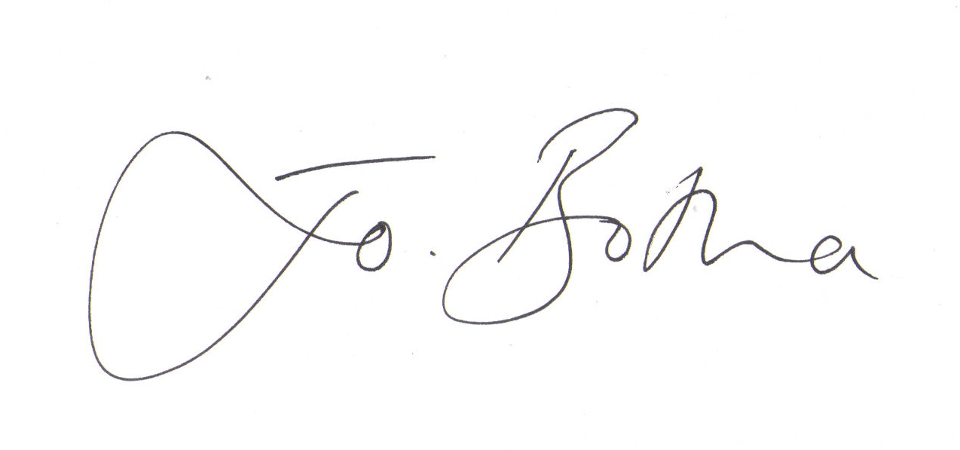
Joanna Botha, Clerk/Responsible Financial Officer

