To all Great Milton Parish Councillors:

You are summonsed to attend a PARISH COUNCIL MEETING on Monday 13th September 2010 at 7.30pm in the Pavilion:

AGENDA
97/10 Apologies for Absence
To receive apologies for absence from the meeting

98/10 Register of Interests for this Meeting
To receive declarations of interest in matters on the Agenda

99/10 Minutes of the Previous Meeting
To approve and sign minutes of the meeting held Monday 12th July 2010.

100/10 Matters to Report
To receive an update on actions since the last meeting not appearing as Agenda items and reports from District and County Cllrs if present.

101/10 Correspondence and Public Discussion
To receive items of correspondence and take questions from the public.

102/10 Planning Applications
A To receive and consider the following Planning Applications:

Chilworth Farm, Great Milton, OX44 7JH. P10/W1066
Chilworth Farm, Great Milton, OX44 7JH. P10/W1067/LB
Brook Bank, Church Road, Great Milton, OX44 7PB. P10/W0636 (Amended)
Chilworth House School, Thame Road, Wheatley, OX33 1JP. P10/W1159
The Pavilion, Recreation Ground, Great Milton, OX44 7NF. P10/W1124

B To review the following Planning Decisions received:

Planning permission has been GRANTED by OCC for the proposed development at Great Milton C of E Primary School, subject to a number of conditions. County Council reference R3.0188/09. District Council reference P09/W0843/CC.

C To receive any further updates on outstanding applications.

103/10 Pegswell Lane
A To discuss quotations received for the required work and to agree a course of action for undertaking the necessary repairs and improvements.

104/10 SODC Grant Agreement for the Pavilion Refurbishment
A To formally resolve to sign the SODC Grant Agreement Contract as Custodian Trustee of the Recreation Ground.

105/10 Review of The Bulletin Advertising Rates
A To review and agree any changes to The Bulletin advertising rates to coincide with the change to an A5 format and to consider the costings for a colour advert on the back page.

106/10 Grass Cutting Contracts
A To consider a proposal from Little Milton Parish Council to ask contractors to quote for cutting Little Milton, Great Haseley and Great Milton Parishes as well as for an individual parish, to see whether there are any savings to be made.

107/10 Replacement Litter Bin for the Green
To discuss the need to replace the litter bin on the Green, consider the options available and approve any expenditure.

108/10 Financial Resolutions
A To approve the payment of funds held for the Pavilion Refurbishment project to the Great Milton Recreation Ground Management Committee.
B To authorise cheques for payment.
C To review the Action Plan drawn up from the Internal Auditor’s recommendations.
D To review and agree whether to adopt the NALC’s Model Financial Regulations as amended for Great Milton Parish Council.

109/10 Any Other Business

All members of the press and public are very welcome at this meeting. The date of the next Great Milton Parish Council meeting will be Monday October 11th at 7.30pm in the Pavilion.

Signed:
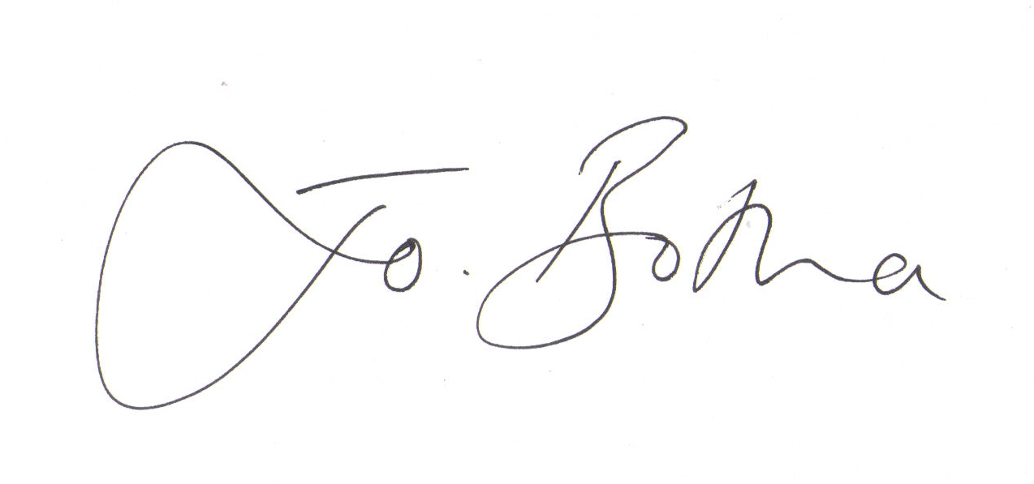
Joanna Botha, Clerk/Responsible Financial Officer

