To all Great Milton Parish Councillors:

You are summonsed to attend a PARISH COUNCIL MEETING on Monday 19th September 2011 at 7.30pm in the Pavilion:

88/11 Apologies for Absence
To receive apologies for absence from the meeting.

89/11 Register of Interests for this Meeting
To receive declarations of interest in matters on the Agenda.

90/11 Minutes of the Previous Meetings
To approve and sign minutes of the meeting held Monday 18th July 2011 and the Planning Meeting held Monday 15th August 2011.

91/11 Matters to Report
To receive reports from the local PCSO, District and County Cllrs if present and any updates on actions since the last meeting (not appearing as Agenda items).

92/11 Correspondence and Public Discussion
To take questions from the public and receive items of correspondence.

93/11 Planning Applications
A To consider the following Planning Applications:

Le Manoir Aux Quat’Saisons, Church Road, Great Milton, OX44 7PD. P11/W1277 and P11W1240/LB (Listed Building Consent). Proposed canopy to Dovecot guest suite.

Le Manoir Aux Quat’Saisons, Church Road, Great Milton, OX44 7PD. P11/W1285 and P11W1241/LB (Listed Building Consent). Proposed glazing to ground floor entrance tower to La Belle Epoque Suite.

Land East of Crowthorne Kennels Milton Common (In the parish of Great Milton), OX9 2JX. P11/W0622/RET (Retrospective). Erection of a fence and gates up to 2.4 m high and three storage buildings. Amendment to site plan 26th August 2011.

B To review any planning decisions received.
C To receive any further updates on outstanding planning matters.

94/11 Improvements to the Green by Ardfield
To review the details of the proposed new driveway, agree whether to support it and decide on any necessary action.

95/11 Overgrown Tree on Common Land
To review the quotations and reports received from arboricultural contractors and the guidance from SODC Forestry and then to agree an appropriate course of action.

96/11 Responses to the Parish Plan Questionnaire
To plan the next steps required to achieve a final published plan and to take action on the matters arising from the responses.

97/11 Bus Stop Improvements
To discuss various bus stop matters relating to the stops at Sandy Lane, Potts Close and proposed additional stop on Windmill Hill and agree any action.

98/11 Winter Preparedness
To review and discuss guidelines on winter preparedness, identify a dry storage for a one tonne bag of salt to be provided this season and to consider purchasing extra.

99/11 Financial Resolutions
A To authorise the following cheques for payment:

Joanna Botha. Salary (50% of September pay). £161.09
Joanna Botha. Bulletin advertising (July and Sept issues). £43.74 (5 hours x £8.747)
Jonathan Dudley. Sept Bulletin. TBC
Little Milton Parish Council. 50% of charge for kissing-gate installation. £93.00
mh-p internet. Annual fee for Updating Plan P plus Auto Responder. £522.00
Berinsfield Community Business. Verge cutting 7th June, 5th July, 2nd August, 30th August. £936.00
Countrywide Grounds Maintenance. Recreation Ground Cuts. 7th, 29th July, 10th August. £270.00
SODC. Dog bin emptying. £34.98
Wheatley Park School. Donation for Prize-giving. £30.00

B To review the action plan drawn up from the Internal Auditor’s recommendations.
C To consider the donation requests received during the past six months.

100/11 Any Other Business
This part of the meeting may be used to bring the Clerk’s attention to village maintenance issues, inform the meeting of any notices or diary dates and to propose future agenda items.

All members of the press and public are very welcome at this meeting. The date of the next Great Milton Parish Council meeting will be Monday October 17th 2011 at 7.30pm in the Pavilion.

Signed:
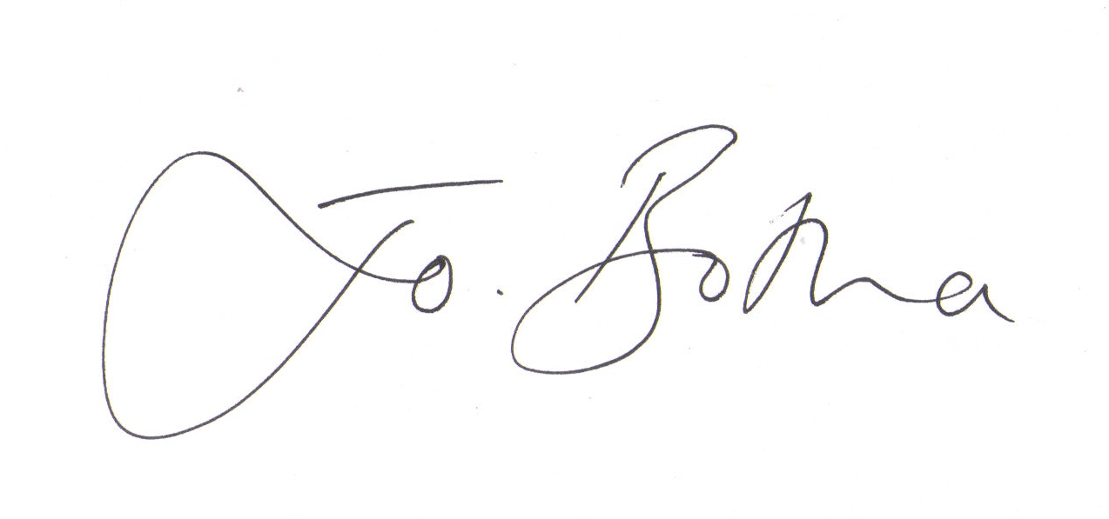
Joanna Botha, Clerk/Responsible Financial Officer

