To all Great Milton Parish Councillors:

You are summonsed to attend the ANNUAL GREAT MILTON PARISH COUNCIL MEETING on Monday 16th May 2011 at 7.30pm in the Pavilion:

AGENDA
45/11 Apologies for Absence

46/11 To Elect a Chairman

47/11 To Elect a Vice-Chairman

48/11 To nominate representatives for:
The Sheppard Trust
The Hard Surface Play Area Committee
Great Milton Recreation Ground Management Committee
The Kent & Couling Charity
The Old Field Charity

49/11 Inventory of Parish Documents
To confirm the inventory of documents held by the Clerk and County Records Office.

50/11 Revision of Standing Orders
To consider the Parish Council’s Standing Orders and make revisions as necessary.

51/11 Revision and Confirmation of Insurance Arrangements
To consider the Parish Council’s insurance arrangements and make revisions as necessary.

52/11 Register of Interests for this Meeting
To receive declarations of interest in matters on the Agenda.

53/11 Minutes of the Previous Meeting
To approve and sign the minutes of the meeting held on Monday 11th April 2011.

54/11 Matters to Report
To receive an update on matters progressed since the last meeting not appearing as Agenda items and reports from District and County Cllrs if present.

55/11 Correspondence and Public Discussion
To receive items of correspondence and take questions from the public.

56/11 Planning Applications
A To receive and consider the following Planning Applications:

The Oxford Belfry Hotel Milton Common (In the parish of Tiddington with Albury) OX9 2JW. P11/W0510/EX. Extension of time to implement planning permission P07/W1416. Construction of new two storey staff accommodation building and storage buildings to replace existing.

Kings Head House, High Street, Great Milton, OX44 7NF. P11/W0322 & P11/W0323/LB. Erection of a rear extension to existing utility room.

Westlands, Lower End, Great Milton, OX44 7NJ. P11/W0565. Repositioning and amendments to building approved under application reference P10/W1382 (Demolition of existing garage and replacement with new garage and garden room).

The Pavilion, Recreation Ground, Great Milton, OX44 7NJ. P11/W0590/RET. Replacement of existing roof material with 'Athy Ecoslate', insertion of roof light and creation of two doors to allow access to the sport changing rooms from outside (amendment to planning permission P10/W1124 for the roof light addition).

Land East Crowthorne Kennels, Milton Common, OX9 2JX. P11/W0621/RET. Use for the storage of various items in connection with a vehicle recovery contractors business.

B To review any Planning Decisions received.

C To receive and discuss any further updates on planning matters including concerns raised by residents regarding the development of agricultural buildings at Oxen Field, Thame Road, Great Milton (P06/W0135); and correspondence regarding the development at Chilworth House School.

57/11 Pegswell Lane
To review the preferences of local residents on the management of the definitive footpath at Pegswell Lane and agree a course of action.

58/11 The Bulletin
To consider and agree on interim arrangements for the management of editorial and advertising for The Bulletin.

59/11 Second set of wooden posts for The Green
To review the quotation received for installing wooden posts on The Green by ‘Ardfield’ and to agree any action.

60/11 Financial Resolutions
A To authorise cheques for payment:

Joanna Botha. Salary. £322.18
Joanna Botha. Bulletin editorial. TBC
Jonathan Dudley. Bulletin production. TBC
Jonathan Dudley. Parish Plan questionnaire. £60.00
Spade Oak. Resurfacing Rec Entrance. £1,740.00
Recreation Ground Management Committee. Insurance. £882.85
SODC. Dog bin emptying. £34.98

B To review and approve the Internal Audit Plan.

C To consider and agree on a 50 per cent contribution towards the installation of a kissing-gate on the extended footpath between Little Milton and Great Milton.

61/11 Any Other Business

All members of the press and public are very welcome at this meeting.

The next meeting of the Great Milton Parish Council will be held on Monday June 13th 2011 starting at 7.30pm in The Pavilion.

Signed:
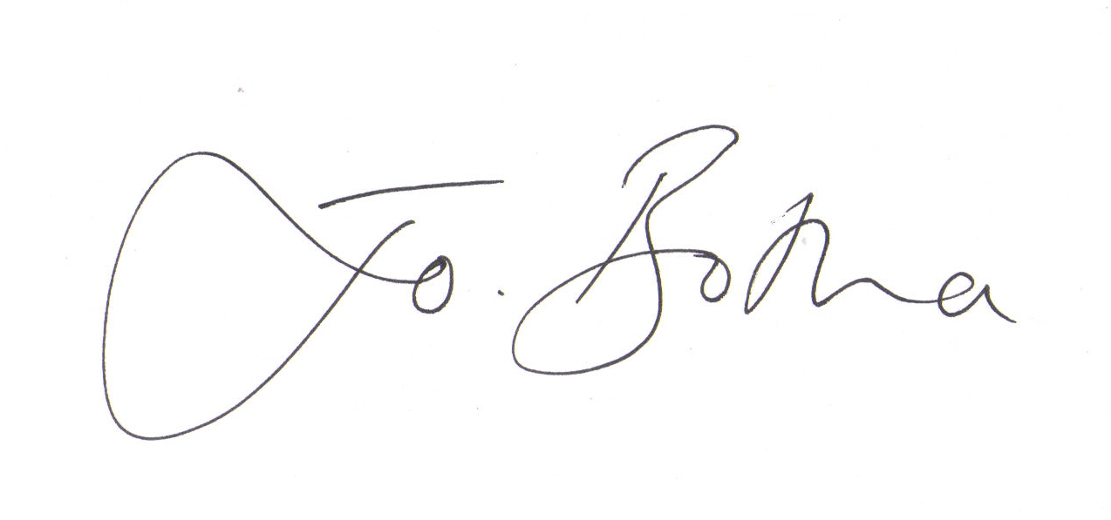

Joanna Botha
Clerk/Responsible Finance Officer to Great Milton Parish Council

