To all Great Milton Parish Councillors:

You are summonsed to attend a PARISH COUNCIL MEETING on Monday 17th October 2011 at 7.30pm in the Pavilion:

101/11 Apologies for Absence
To receive apologies for absence from the meeting.

102/11 Register of Interests for this Meeting
To receive declarations of interest in matters on the Agenda.

103/11 Minutes of the Previous Meetings
To approve and sign minutes of the Planning Meeting held Monday 15th August 2011 and the Parish Council meeting held Monday 19th September 2011.

104/11 Matters to Report
To receive reports from the local PCSO, District and County Cllrs if present and any items progressed since the last meeting (not appearing as Agenda items).

105/11 Correspondence and Public Discussion
To take questions from the public and receive items of correspondence.

106/11 Planning Applications
A To consider the following Planning Application:

Plum Tree Cottage, Thame Road, Great Milton, OX44 7NU. P11/W1465. Alterations to garage. Demolish left hand wall and widen garage. Remove existing asbestos sheet roof and install new roof structure and tiled/felt roof. Replace existing concrete drive with gravel, including removing side shrub wall.

B To review any planning decisions received.

C To receive any further updates on outstanding planning matters.

107/11 Improvements to the Green by Ardfield
To consider and agree whether to meet the £150 cost of planning permission if this should be required for the dropped kerb.

108/11 Winter Preparedness
To reconsider the storage location for a one tonne bag of salt to be provided this season and to discuss the possible alternatives to salt bins.

109/11 Great Milton Bus Shelters
To review the responses to the village bus shelter consultation and agree any necessary action.

110/11 The Bulletin
A To review the revised production arrangements for the Great Milton Bulletin, discuss and agree the expenditure.

B To further discuss the charging policy for advertising not-for-profit events and activities in order to provide clarification to village groups.

111/11 Facilities for Young People in Great Milton
To discuss the provision for young people within the parish, the feasibility of any additional provision and propose any action to be taken.

112/11 Financial Resolutions
A To authorise the following cheques for payment:

Joanna Botha. Salary (50% of September pay and October pay). £483.27
Joanna Botha. Bulletin advertising, October issue. £26.24 (3 hours x £8.747)
Joanna Botha. Expenses. TBC
Jonathan Dudley. September and October Bulletins. TBC
Thames Water Utilities. £17.53
Countrywide Grounds Maintenance. Recreation Ground Cuts. TBC
BDO. External audit. TBC
St. John Ambulance. Donation. £30.00
Oxfordshire Association for the Blind. Donation. £30.00
Oxfordshire Carers Forum. Donation. £30.00

B To review and approve a quarterly bank reconciliation and analysis of actual receipts/payments versus budget.

C To review and approve the conclusion of the external audit (Annual Return Year-ending 31st March 2011).

113/11 Any Other Business
This part of the meeting may be used to bring the Clerk’s attention to village maintenance issues, inform the meeting of any notices or diary dates and to propose future agenda items.

All members of the press and public are very welcome at this meeting. The date of the next Great Milton Parish Council meeting will be Monday November 21st 2011 at 7.30pm in the Pavilion.

Signed:
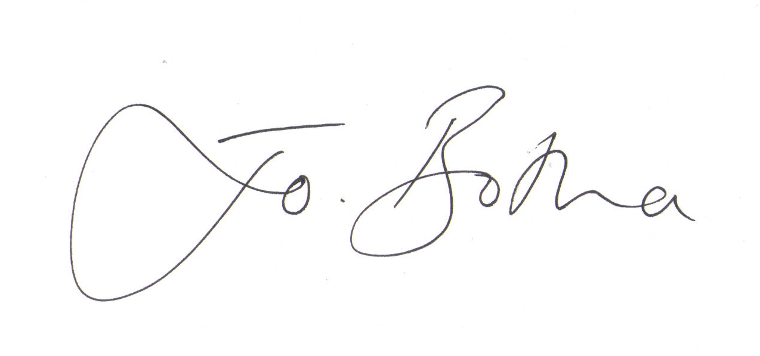
Joanna Botha, Clerk/Responsible Financial Officer

