To all Great Milton Parish Councillors:

You are summonsed to attend a PARISH COUNCIL MEETING on Monday 11th April 2011 at the earlier time of 7pm in the Pavilion. This meeting will be followed by the Annual Parish Meeting at 8pm.

AGENDA
35/11 Apologies for absence
To receive apologies for absence from the meeting.

36/11 Register of interests for this meeting
To receive declarations of interest in matters on the Agenda.

37/11 Minutes of the previous meeting
To approve and sign minutes of the meeting held Monday 14th March 2011.

38/11 Matters to report
To receive reports from District and County Cllrs if present and an update on actions since the last meeting not appearing as Agenda items, including:

Royal Wedding street party, litter pick, parish plan, bus service review, matters reported to Highways, repositioning of electric cables.

39/11 Correspondence and public discussion
To take questions from the public and receive items of correspondence.

40/11 Planning applications
A To consider the following planning applications:

Tallis House, High Street, Great Milton, OX44 7NF. P11/W0314 & P11/W0315/LB (listed building consent). Extension and refurbishment of listed house, reinstatement as single
dwelling, removal of porch, alteration of roof line.

B To review any planning decisions received.

C To receive any updates on outstanding planning matters.

41/11 The Bulletin team
To discuss and decide on appointments to the Bulletin editorial and production team.

42/11 Financial resolutions
A To authorise the following cheques for payment:

Joanna Botha. March salary. £314.74
Jonathan Dudley. April Bulletin. TBC
ORCC. Subscription. £30
Oxford Greenbelt Network. Subscription. £15

B To review and approve a quarterly bank reconciliation with analysis of actual receipts/payments versus budget.

C To review and approve a minor amendment to the Financial Regulations.

D To approve an increase of one salary point to the Clerk’s pay in accordance with her employment contract, to NJC salary point LC1.17 (8.747 pence per hour).

43/11 Donation requests
To discuss and agree whether to grant donation requests from Sue Ryder - Nettlebed Hospice, Oxfordshire Business Education Alliance, Open Spaces Society, Thame & District Citizens Advice Bureau, South & Vale Carers Centre and Ryder-Cheshire Volunteers Oxfordshire.

44/11 Any other business
This part of the meeting may be used to bring the Clerk’s attention to village maintenance issues, inform the meeting of any notices or diary dates and to propose future agenda items.

All members of the press and public are very welcome at this meeting.

Due to the timing of the elections, the Annual Meeting of the Parish Council will be held on the third Monday in May rather than the second - Monday May 16th 2011 at 7.30pm in the Pavilion.

Signed:
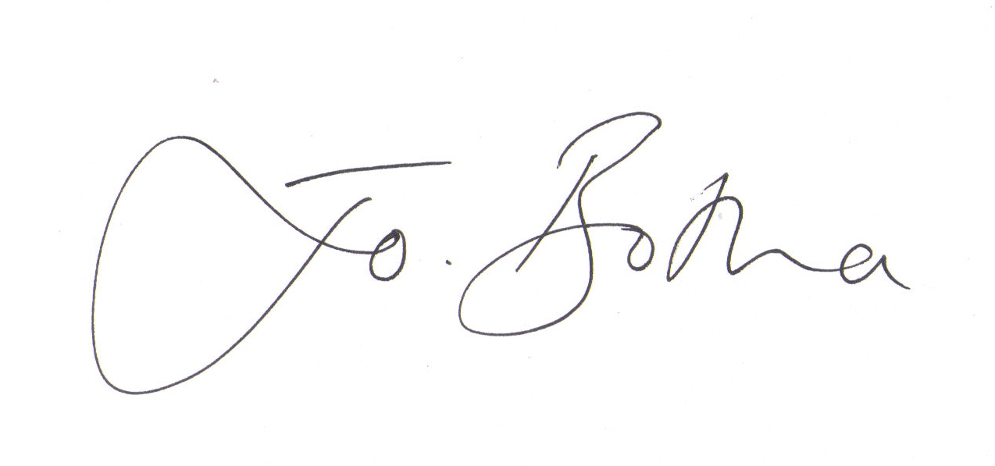
Joanna Botha, Clerk/Responsible Financial Officer

