To all Great Milton Parish Councillors:

You are summonsed to attend a PARISH COUNCIL MEETING on Monday 14th February 2011 at 7.30pm in the Pavilion:

AGENDA
12/11 Apologies for Absence
To receive apologies for absence from the meeting.

13/11 Register of Interests for this Meeting
To receive declarations of interest in matters on the Agenda.

14/11 Minutes of the Previous Meeting
To approve and sign minutes of the meeting held Monday 10th January 2011.

15/11 Matters to Report
To receive reports from District and County Cllrs if present and an update on actions since the last meeting not appearing as Agenda items, including the following:

- Extension of leases for school playground and new MUGA
- Resurfacing work on Recreation Ground entrance
- Parish Plan
- Pegswell Lane Grant Application
- Joint approach (with Little Milton and Great Haseley) to grounds maintenance contractors for quotations for cutting the Recreation Ground.
- Procedures for forthcoming Parish Council elections

16/11 Correspondence and Public Discussion
To take questions from the public and receive items of correspondence, including the following:

- Letter from the Local Government Boundary Commission about the Electoral
Review of Oxfordshire

17/11 Planning Applications
A To consider the following Planning Application:

Northend Cottage, Lower End, Great Milton, OX44 9NP. P11/W0088. Single storey timber outbuilding.

B To review any Planning Decisions received.

C To receive any further updates on outstanding applications.

18/11 Litter Pick
To finalise the date for this year’s litter pick, review the prices of litter pickers and decide whether to purchase any for use by residents of the Parish.

19/11 New Web Site Pricing Structure
To review and consider the new price plan options from web company Mike Henson Presentations and decide whether to change the existing plan.

20/11 Estimate for Village Maintenance
To consider the estimated costs of village maintenance for 2011-12 and agree a system for contracting out the work.

21/11 Financial Resolutions
A To authorise the following cheques for payment:

Joanna Botha. Salary. £314.74
Manuel Stone. February Bulletin. £50
Jonathan Dudley. February Bulletin. TBC
Mike Henson Presentations. Adding 2011 meeting dates. £18
Thames Water. Allotment supply Sept-Dec. £11.99
SODC. Dog hygiene bin emptying (Oct-Dec 10). £34.25
Spade Oak. Recreation entrance resurfacing. £1,830

B To review and approve a revised Risk Management document.

C To review and approve a new Fixed Asset Register.

D To review the progress of the Action Plan drawn up from the Internal and External Auditor’s recommendations.

22/11 Any Other Business
This part of the meeting may be used to bring the Clerk’s attention to village maintenance issues, inform the meeting of any notices or diary dates and to propose future agenda items.

All members of the press and public are very welcome at this meeting. The date of the next Great Milton Parish Council meeting will be Monday March 14th 2011 at 7.30pm in the Pavilion.

Signed:
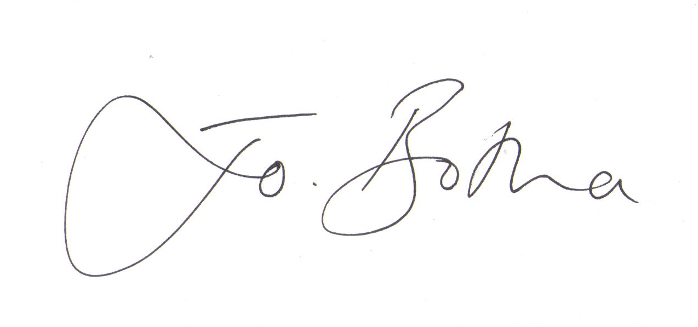
Joanna Botha, Clerk/Responsible Financial Officer

