To all Great Milton Parish Councillors:

You are summonsed to attend a PARISH COUNCIL MEETING on Monday 16th July 2012 at 7.30pm in the Pavilion:

AGENDA
78/12 Apologies for Absence

79/12 Register of Interests for this Meeting
To receive declarations of interest in matters on the Agenda and to provide notice of disclosable pecuniary interests which are required to be notified to the monitoring officer further to the provisions of the Localism Act 2011 and the Relevant Authorities (Disclosable Pecuniary Interests) Regulations 2012.

80/12 Minutes of the Previous Meeting
To approve and sign the minutes of the PC meeting held on Monday 18th June 2012.

81/12 Matters to Report
To receive an update on matters progressed since the last meeting not appearing as Agenda items and reports from District and County Cllrs if present.

82/12 Correspondence and Public Discussion
To receive items of correspondence and take questions from the public.

83/12 Planning Applications
A To consider the following Planning Applications:

10 Thame Road, Great Milton, OX44 7HY. P12/S1199/HH (Householder). Single and two storey rear extensions, alterations to the front porch roof and addition of high level windows to side.

Wheatley Farm Shop, Old London Road, Wheatley, OX33 1DW. P12/S1070/FUL (Full Application). Demolition of stables (three blocks), storage buildings, containers,
structures and kennels. Erection of multipurpose agricultural storage building and
stables with additional soft landscaping.

Unit 12, Ashurst Court, London Road, Wheatley (in the parish of Great
Milton) OX33 1ER. P12/S1338/FUL (Full Application). Demolition of existing building. Erection of replacement building to be used for B1 purposes.

B To review any planning decisions received and any outstanding planning matters.

84/12 Great Milton Parish Plan
To review the progress made on the actions cited within the Parish Plan, to ensure that someone is available to take a lead on each item and to review the timetable.

85/12 Youth Facilities
To review a draft consultation on youth facilities in the parish of Great Milton.

86/12 Financial Resolutions
A To authorise cheques for payment:

Joanna Botha. Salary. £367.20
Joanna Botha. Expenses. TBC
Jonathan Dudley. Bulletin production June and July issues. TBC
Windmill Landscapes. Hedge Cutting (Urgent). £54.00
MDS Builders. Reimbursement of advertising fees. £30.00

B To review a quarterly bank reconciliation and analysis of actual receipts/payments versus budget.

C To receive the internal auditor’s management report for the year-ending March 31st 2012.

87/12 Any Other Business
This part of the meeting may be used to bring the Clerk’s attention to village maintenance issues, inform the meeting of any notices or diary dates and to propose future agenda items.

All members of the press and public are very welcome at this meeting.

The next meeting of the Great Milton Parish Council will be held on Monday September 17th 2012 starting at 7.30pm in The Pavilion.

Signed:
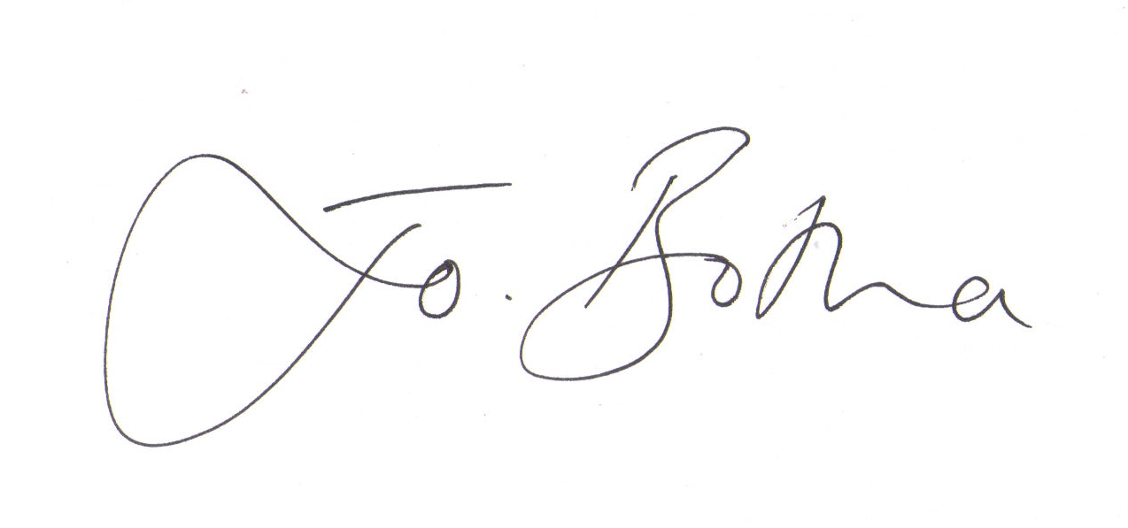

Joanna Botha
Clerk/Responsible Finance Officer to Great Milton Parish Council

