To all Great Milton Parish Councillors:

You are summonsed to attend the ANNUAL GREAT MILTON PARISH COUNCIL MEETING on Monday 10th May 2010 at 7.30pm in the Pavilion:

AGENDA
52/10 Apologies for Absence
To receive apologies for absence from the meeting

53/10 To Elect a Chairman

54/10 To Elect a Vice-Chairman

55/10 To nominate representatives for:

The Sheppard Trust
The Hardsurface Play Area
The Great Milton Recreation Ground Management Committee
The Kent & Couling Charity
The Old Field Charity

56/10 Inventory of Parish Documents
To confirm the inventory of documents held by the Clerk and County Records Office.

57/10 Revision of Standing Orders

A To consider the Parish Council’s Standing Orders and make revisions as necessary.

B To decide whether to pass a resolution that service of summons on councillors confirming the time, date, venue and the agenda for a meeting by delivery or post at their residences at least 3 clear days before a meeting is not expedient and therefore that a summons confirming the time, date, venue and the agenda of a meeting of the Council may be served on Councillors at least 3 clear days before the meeting provided any such email contains the electronic signature and title of the Proper Officer.

58/10 Revision and Confirmation of Insurance Arrangements
To consider the Parish Council’s current insurance arrangements and make revisions as necessary.

59/10 Register of Interests for this Meeting
To receive declarations of interest in matters on the Agenda

60/10 Minutes of the Previous Meeting
To approve and sign the minutes of the meeting held on Monday 19th April 2010.

61/10 Matters to Report
To receive an update on matters progressed since the last meeting not appearing as Agenda items and reports from District and County Cllrs if present.
62/10 Correspondence and Public Discussion
To receive items of correspondence and take questions from the public.

63/10 Planning Applications
A To receive and consider the following Planning Applications:

Tudor Cottage, 1 London Road, Wheatley OX33 1JJ. P10/W0471
Infill of existing porch with WC extension.

Bentley House, London Road, Milton Common, OX9 2NU. P10/W0443
Demolition of existing rear extension. Removal of existing roof to main
house and garage. Erection of new 2 storey rear extension including raising of
existing roof height. New roof and front dormers and new porch. Removal of existing
chimney and new pitched roof over garage.

Land East of Crowthorne Kennels, Milton Common, OX9 2JX. P09/W1143/RET
Erection of a 3 metre high security fence, 3 storage buildings and raising levels to the southern part of the site by a maximum of 54 mm.

Land East of Crowthorne Kennels Milton Common OX9 2JX4. P10/W0493/RET
Use of site by vehicle recovery contractor.

The Cottage, Church Road, The Green. Great Milton. OX44 7NT. P10/W0514
Change of use from office to ancillary residential and single storey extension to rear.

The Cottage, Church Road, The Green, Great Milton OX44 7NT. P10/W0516/LB
Conversion of office to ancillary residential and single storey extension to rear.

Springfield Barn, London Road, Milton Common (in the parish of
Great Milton) OX9 2J. P10/W0583/LD
Extension to building.

B To review the following Planning Decisions received:

Planning permission has been GRANTED by SODC for Hollands Farm Great Milton OX44 7NR. P10/W0275/RET. New replacement agricultural dwelling on site of existing barn.

C To receive any further updates on outstanding applications.

64/10 Parking on the Green

A To review the impact of the recent letters advising residents not to park on the Village Green and to agree any further action necessary.

65/10 Safety on the Junction of Church Road and A329

A To discuss the problems with this junction and agree any action that can be taken by the Parish Council.

66/10 Contract of employment for the Clerk

A To consider adopting the NALC model contract for the Clerk and to amend as necessary.

67/10 Financial Resolutions

A To authorise cheques for payment

B To agree the appointment of an internal auditor and to receive an update from the Clerk on the procedures for the forthcoming External Audit.

C To review and approve the year-end accounts.

68/10 Any Other Business

All members of the press and public are very welcome at this meeting.

The next meeting of the Great Milton Parish Council will be held on Monday June 14th starting at 7.30pm in The Pavilion.

Signed:
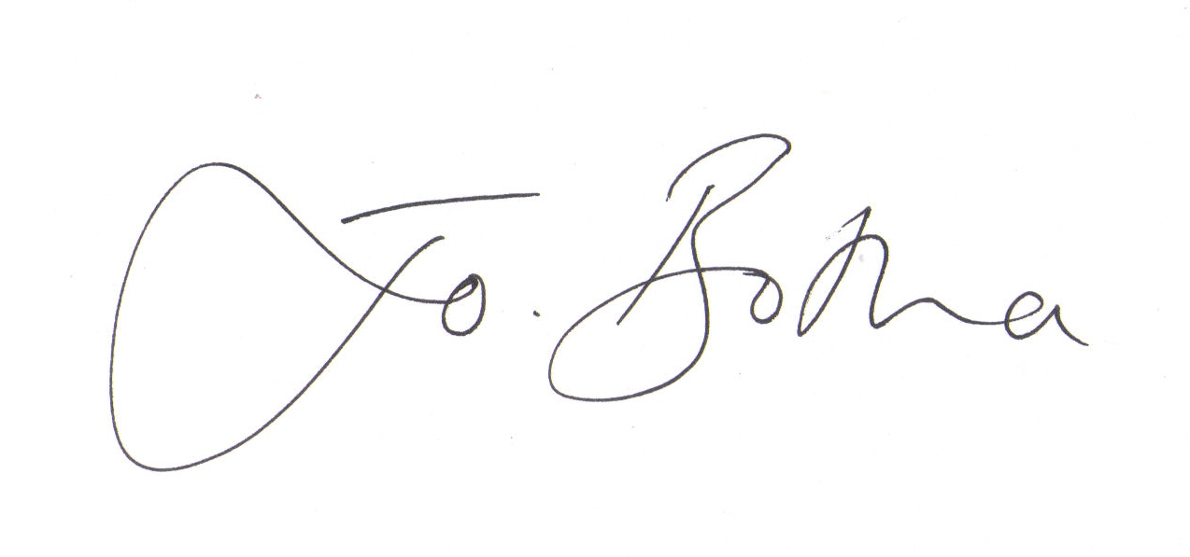

Joanna Botha
Clerk/Responsible Finance Officer to Great Milton Parish Council

