12/10/2022

To the Chairman and members of Great Milton Parish Council

Dear Councillor

You are hereby summoned to the next meeting of Great Milton Parish Council, to be held at the Pavilion, Recreation Ground, Great Milton on Monday 17th October 2022.

Public and Press are welcome to attend.

Yours sincerely,
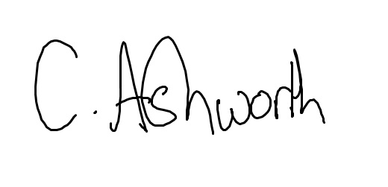
Chris Ashworth
Clerk & Responsible Finance Officer to Great Milton Parish Council

AGENDA

131/22 Apologies for absence

132/22 Variation of order of business

133/22 Declarations of members’ interests
To receive declarations of interest in matters on the Agenda.

134/22 Matters to report
To receive reports from County and District Councillors and other bodies as appropriate.

135/22 Correspondence and public discussion

136/22 Planning applications
A P22/S3601/LB (3 Priory Bank Church Road Great Milton OX44 7PA) New chimney pot to extend height above ridge to current regulatory height for a wood burner.

B To review the following planning decisions received and any outstanding planning matters:

137/22 Minutes of the previous meeting
To approve the minutes of the September meeting of the Parish Council, held on 26th September 2022, as a true and accurate record of proceedings.

138/22 Financial resolutions
A To authorise and sign the following cheques for payment:
Chris Ashworth. Salary, Tax and Expenses October: £517.22
Shield Maintenance Dog Waste October: £62.40
Jonathon Dudley Bulletin production October: £tbc
McCracken & Sons. Mowing September: £tbc
BT Office/e-mail package: £10.80 (paid by monthly Direct Debit)
Hugo Fox: web support July: £19.99 (paid by monthly Direct Debit)

B To receive the monthly bank reconciliation, accounts and bank statement.

139/22 Priorities for the financial year 2023/24
To consider the Parish Council’s financial priorities for the coming year, the initial step in the 2023/2024 budget preparation process.

140/22 Parish clerk and councillors’ update of matters in hand
- Work on the 20mph scheme is ongoing. Great Milton’s scheme is scheduled to be implemented in by the end of the year.
- Work on the gateway features has been raised with the signing contractor. It will take a few weeks for necessary materials to be acquired then we will be given a date of installation.
- The Great Milton Christmas Carols around the tree on the green followed by mince pies in the pub will take place on Tuesday 13th December at 18:00.

141/22 Security in the village
To update on and discuss any security-related issues.

142/22 Funding for the youth club
To discuss the potential of funding for Great Milton Youth Club.

143/22 Warm welcome campaign
To discuss putting in place an initiative for the warm Welcome Campaign. The campaign is about making properly heated communal facilities available to those who can't afford to heat their homes all day, eg, having the pavilion, the Neighbours Hall, the Methodist Church and/or, yes, even the pub, available at certain times where the more vulnerable in the village can take refuge, not only for the purposes of keeping warm but socialising generally.

144/22 Thame food bank initiative
To discuss the potential of setting up a food bank donation point within the Parish, which will be collected by Cllr Caroline Newton.

145/22 Code of conduct
To consider the new code of conduct.

146/22 Community Infrastructure Levy (CIL)
To be aware we have the CIL to draw upon when a future project comes up

The next meeting of Great Milton Parish Council will be held on Monday 21st November 2022 at 7.30 pm at the Pavilion.

