To all Great Milton Parish Councillors:

You are summonsed to attend a PARISH COUNCIL MEETING on Monday 8th November 2010 at 7.30pm in the Pavilion:

AGENDA
122/10 Apologies for Absence
To receive apologies for absence from the meeting.

123/10 Register of Interests for this Meeting
To receive declarations of interest in matters on the Agenda.

124/10 Minutes of the Previous Meeting
To approve and sign minutes of the meeting held Monday 11th October 2010.

125/10 Matters to Report
To receive reports from District and County Cllrs if present and an update on actions since the last meeting not appearing as Agenda items.

126/10 Correspondence and Public Discussion
To take questions from the public and receive items of correspondence, including the following:

Letter of thanks from St. John Ambulance, Reply from ASM Auto Recycling, Electoral Review of Oxfordshire, Consultation on Concessionary Fares Scheme, Annual Report from M40 CEG including a donation request, Email from allotment initiative ‘Landshare’.

127/10 Planning Applications
A There are no Planning Applications to consider this month.

B To review the following Planning Decisions received:

Chilworth Farm, Great Milton, OX44 7JH. P10/W1066 & W/1067/LB. (Granted)
Chilworth House School, Wheatley, OX33 1JP. P10/W1159. (Granted)
Lantern Service Station, Milton Common, OX9 2JL. P10/W0318. (Refused)

C To receive any further updates on outstanding applications.

128/10 Recreation Ground Accessway and Making Good the Green
To review and discuss the next steps required to progress these projects.

129/10 Village Maintenance Tasks
A To review the list of tasks usually undertaken by the Village Handyman and discuss what needs to be actioned.

130/10 Christmas Tree
To discuss the acquisition of this year’s Christmas Tree for the Green.

132/10 Financial Resolutions
A To authorise the following cheques for payment:

Joanna Botha. Salary. TBC
Joanna Botha. Expenses. TBC
Neighbours Hall Committee. Parish Plan Meeting. £20.00
Mike Henson Presentations. Planning Archive. £41.13
Manuel Stone. November Bulletin. £50.00
Jonathan Dudley. November Bulletin. TBC

B To discuss the reply from Berinsfield regarding the level of service received and authorise the following payments:

Berinsfield. Verge Grass Cutting (August). £229.13
Berinsfield. Verge Grass Cutting (Sept). £152.75 (33% reduction)

C To review the Action Plan drawn up from the Internal and External Auditor’s recommendations.

D To review the Effectiveness of the Internal Audit.

E To discuss the precept for 2011-12 and review and make amendments as necessary to the draft budget for 2011-12.

133/10 Any Other Business

All members of the press and public are very welcome at this meeting. The date of the next Great Milton Parish Council meeting will be Monday December 13th at 7.30pm in the Pavilion.

Signed:
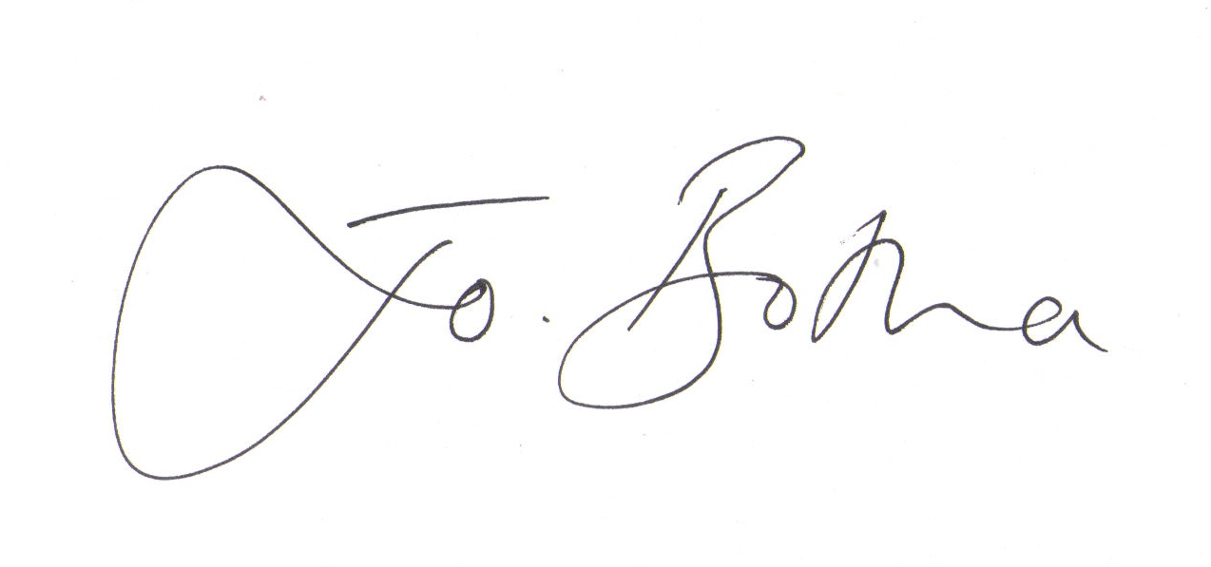
Joanna Botha, Clerk/Responsible Financial Officer

