To all Great Milton Parish Councillors:

You are summonsed to attend a PARISH COUNCIL MEETING on Monday 14th March 2011 at 7.30pm in the Pavilion:

AGENDA
23/11 Apologies for Absence
To receive apologies for absence from the meeting.

24/11 Register of Interests for this Meeting
To receive declarations of interest in matters on the Agenda.

25/11 Minutes of the Previous Meeting
To approve and sign minutes of the meeting held Monday 14th February 2011.

26/11 Matters to Report
To receive reports from District and County Cllrs if present and an update on actions since the last meeting not appearing as Agenda items, including the following:

Parish Plan, Mobile Library, New Web Site Price Plan, Litter Pick

27/11 Correspondence and Public Discussion
To take questions from the public and receive items of correspondence.

28/11 Planning Applications
A To consider the following Planning Applications:

The Old Stores, The Green, Great Milton, OX44 7NT. P11/W0178. Removal of existing greenhouse and garden shed. Erection of replacement greenhouse.

Lantern Service Station, London Road, Milton Common (in the Parish of Great Milton), OX9 2JL. P11/W0091. Erection of 1.8m high green pallisade fence on frontage at gates.

Milton Common Outstation, Three Pigeons Motorway Compound, Milton Common (in the Parish of Great Milton), OX9 2JN. P10/W1624/RET. Replacement of original temporary planning permission for the outstation at Milton Common (ref: P05/W0951) with a permanent consent to support Highways Agency eastern traffic operations.

The Bull, The Green, Great Milton, OX44 7NS. P11/W0259/LB (Listed Building Consent). Proposed internal precautions work.

B To review the following Planning Consultations:

Harrington Farm, Great Milton, OX44 7JE. P11/W0241/AG (agricultural notification). Building for cattle housing and handling yard.

Notification of Enforcement Appeal: Lantern Service Station, London Road, Milton Common, OX9 2JL. P11/W0288/DA. Alleged breach: Change of use from Service Station to Car Sales. Appeal reference number: APP/Q3115/C/11/2147832.
C To review any Planning Decisions received.

D To discuss concerns raised by residents regarding the development of agricultural buildings at Oxen Field, Thame Road, Great Milton (P06/W0135).

29/11 Removal of White Lines in the Road
To discuss and consider whether to ask Highways to proceed with the above traffic calming option, suggested by the Highways Traffic Engineer.

30/11 Repositioning of Overhead Electric Cables
To discuss and consider whether to propose to the relevant utilities provider that the local electricity cables be repositioned underground.

31/11 Royal Wedding
To discuss how the Parish Council might contribute to the Royal Wedding celebrations in the Parish.

32/11 Financial Resolutions
A To authorise cheques for payment.

B To review the revised arrangements for PAYE for Council staff.

C To consider a proposed increase in fuel reimbursements for the Three Villages Hospital Car Scheme.

33/11 Grass Cutting Contract – Recreation Ground
To review and compare the quotations received for cutting the Recreation Ground and to decide how to award the contract. (Public not admitted during this item.)

34/11 Any Other Business
This part of the meeting may be used to bring the Clerk’s attention to village maintenance issues, inform the meeting of any notices or diary dates and to propose future agenda items.

All members of the press and public are very welcome at this meeting.

The date of the next Great Milton Parish Council meeting will be Monday April 11th 2011 starting at the earlier time of 7pm, followed by the Annual Parish Meeting at 8pm. Both meetings will be held in the Pavilion.

Signed:
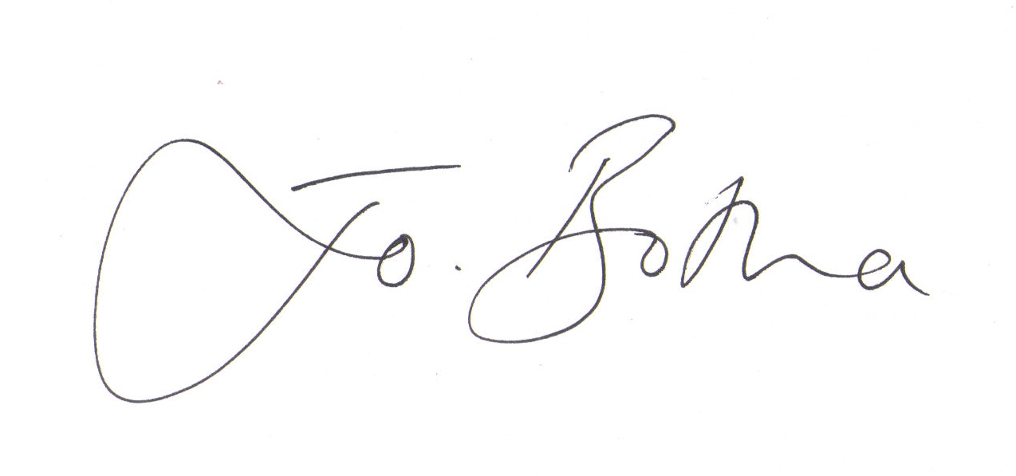
Joanna Botha, Clerk/Responsible Financial Officer

